Student’s Name
Professor’s Name
Course
Date
Comparing and Contrasting Chinese and European Landscaping Art
Eastern Asian and European arts are different as depicted in some of the earliest works done between the 11th and 17th centuries. This essay compares and contrasts the landscape arts from this period with a Chinese landscape painter, Guo Xi, and European painter, Leonardo da Vinci. From the two paintings, the Chinese painter Guo Xi emphasizes revealing the inner world and representation of the mind and spirit, while European painter, Leonardo da Vinci focuses on the outside world and true representation of the physical geography as it appears.
Paintings
Early Spring by Guo Xi (11th century)
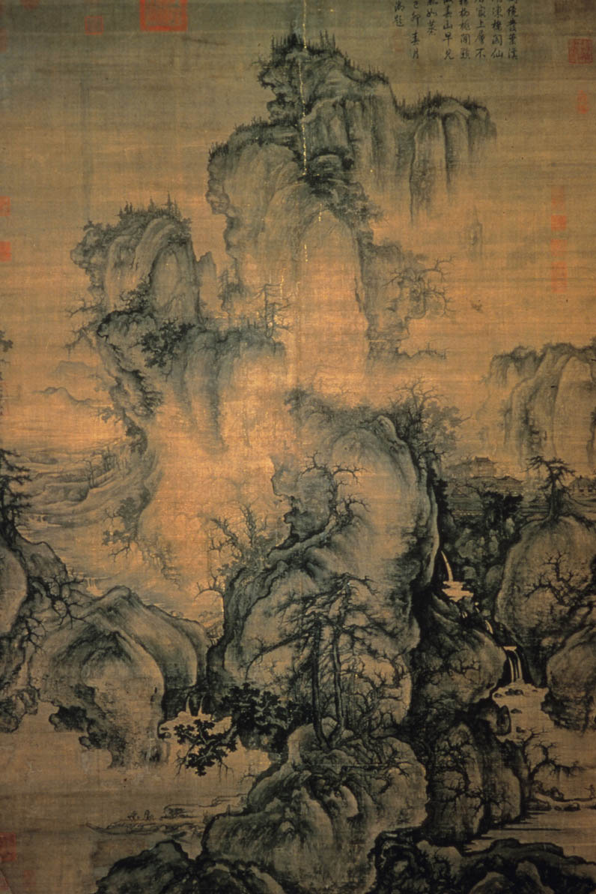

Description
Created in 1072 and made of hanging scroll, ink, and color on silk. The painting, which is currently available at the National Palace Museum in Taipei, Taiwan, was painted following the collapse of the Tang Dynasty which ruled between 618 and 906. This monumental landscape was made under the Northern Song dynasty, during the time that landscape paintings were flourishing in China.
Landscape drawing of Arno Valley by Leonardo da Vinci (15th century)
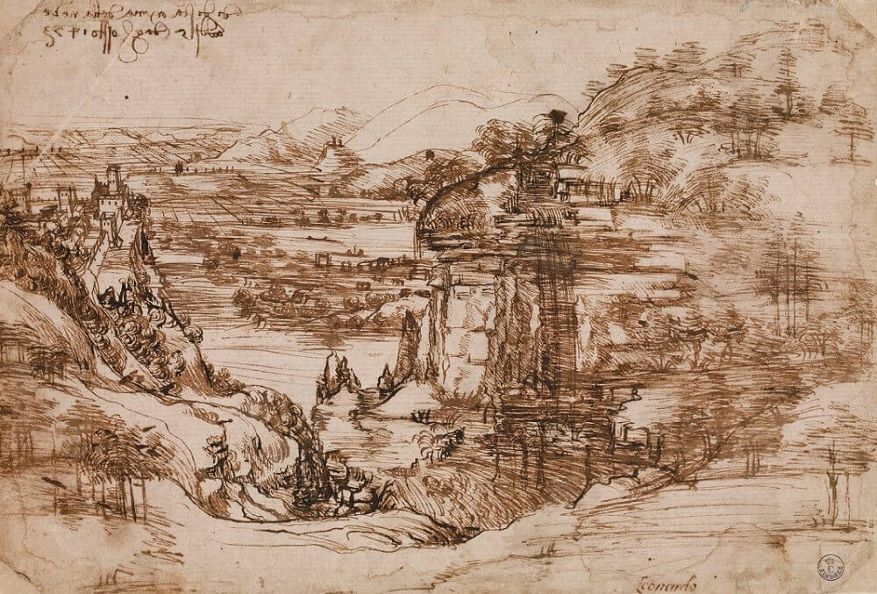
Description
This is one of the earliest known landscaping art done by Leonardo da Vinci. The painting is dated 1473 in the 15th century. This painting is a landscape art drawn with brown ink on paper. The painting is now available at Uffizi Gallery in Florence. The painting depicts Leonardo’s home and by the time he painted this art, he was still living with his family there.
Contrast and Comparison
While the Chinese painting represents the mind and spirit, European painting represents the physical representation of the landscapes. At first, it is difficult to understand or interpret the painting done by Guo Xi because of the texture strokes he has used to build the three-dimensional forms. The strokes have been used to represent or portray cloud-resembling rocks. Xi has used various layers of ink, especially on the soft areas of the painting while also including broad outlines of the boulder merge, which helps to achieve integration.
The concept of beauty is differently understood because of the diverse beliefs of the cultures. Cultural representation of beauty, therefore, differs between cultures and regions. As Bao et al. explain, Western and Chinese have different traditions, which they represent in the world of paintings or art (1596). Western and Eastern use different perspectives to represent the visual world, which as Bao et al. explain, involve geometric and metaphorical sense. This perception can be evidenced in Leonardo’s and Xi’s paintings. In Xi’s painting, the representation of the metaphysical and metaphorical sense is in line with the Chinese concepts of yin and yang, which must balance. These are the two spiritual and complementary dualities that represent the Chinese traditional philosophy. The two must balance, which is what Xi tried to achieve in his painting.
Leonardo’s painting, on the other hand, depicts a representation of the physical appearance of the landscapes in the drawing. Leonardo's understands of geology and the natural world, especially in his immediate environment can be seen in this painting. The painting is quite simple compared to Xi’s painting, in the sense that, it shows the physical appearance of the Valley of the Arno and Montelupo Castle on the left side of the painting. Some people have thought of this painting as a personal experience of Leonardo’s childhood life when he still lived there with his family.
Furthermore, even though both Xi and Leonardo’s paintings involve depiction and representation of valley, the two have employed different approaches to achieve their unique goals and objectives. Xi’s representation of art is based on Chinese representation of the conceptual space. The goal of Xi’s painting is to attain the inner spirit and life, which explains why he uses water and mountain. In Leonardo’s painting, which also represented the valley of the Arno aims to create an illusionistic likeness of the valley. This is very different from Xi’s painting which has a metaphorical meaning; Leonardo’s painting is an illusionistic representation of the valley.
The Western and Eastern philosophies concerning nature are vastly different, as depicted in the two paintings. Xi’s painting represents how man and nature relate to each other in a spiritual way in the landscape. As Trouveroy explains, art in the ancient Chinese kingdoms as part of education, which informs why they are full of hidden meaning and metaphysical concepts. Leonardo’s painting represents the physical beauty of the landscape. However, this philosophy no longer exists because as Memmi explains, a lot of changes have happened in the last centuries (360). Today, there is a lot of cross-cultural borrowing, which depicts how the West influence the East and vice versa. At the same time, some religious, social norms, and even behavior have been retained by each group and these differences are persistent despite the interactions. Despite the differences, it is fair to look at each artwork from a clear perspective without prejudices or stereotypes experienced in the current society.

Works Cited
Bao, Yan, Taoxi Yang, Xiaoxiong Lin, Yuan Fang, Yi Wang, Ernst Pöppel, and Quan Lei. "Aesthetic preferences for Eastern and Western traditional visual art: identity matters." Frontiers in psychology 7 (2016): 1596.
Memmi, Daniel. "Comparative foundations of Eastern and Western thought." AI & SOCIETY 32.3 (2017): 359-368.
Trouveroy, Nathalie. "Landscape of the Soul: Ethics and Spirituality in Chinese Painting." India International Centre Quarterly 30.1 (2003): 5-19.

